35) Aim: To Design Deterministic Finite Automata using simulator to accept strings in which a’s always appear tripled over input {a,b}.

Diagram:

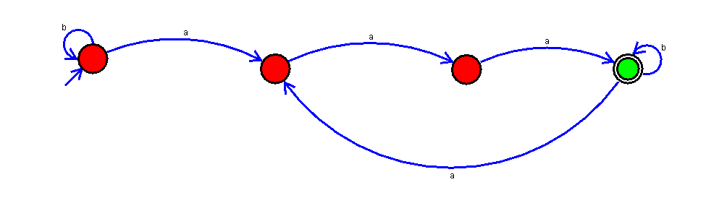

Result:

Successfully executed Deterministic Finite Automata using simulator to accept strings in which a’s always appear tripled over input {a,b}.